**BRINELL HARDNESS TEST**

OBJECTIVE:   
To determine the indentation hardness of mild steel, cast iron, brass, aluminium etc. using Brinell hardness testing machine.

Apparatus used:

|  |  |
| --- | --- |
| Brinell hardness testing machine |  |

**STEP:** **➊** Diameter of the indentor D=10 mm. Select the load P as based on the type of material selected (Mild steel, Cast Iron, Brass, Alluminium).

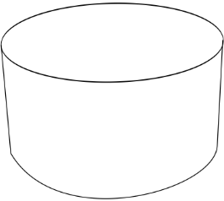

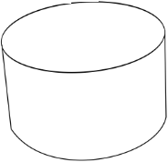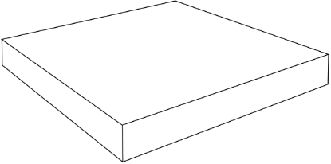

|  |  |
| --- | --- |
| **Material** | **Load ‘P’ (Kg), diameter ‘D’ (mm)**  Diameter of the indentor D=10 mm |
| Cast Iron & mild Steel  Brass, copper & bronze  Aluminum, Magnesium & Zinc | P=30D2 =3000Kg  P=10D2 =1000Kg  P=5D2 =500Kg |

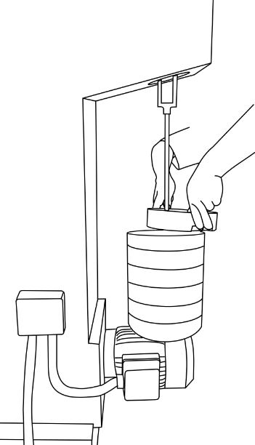

**STEP:** **➋** The specimen is placed on the supporting table. The large hand wheel below the table is turned in clockwise till the gap between the surface of the specimen and the indentor is 5mm.

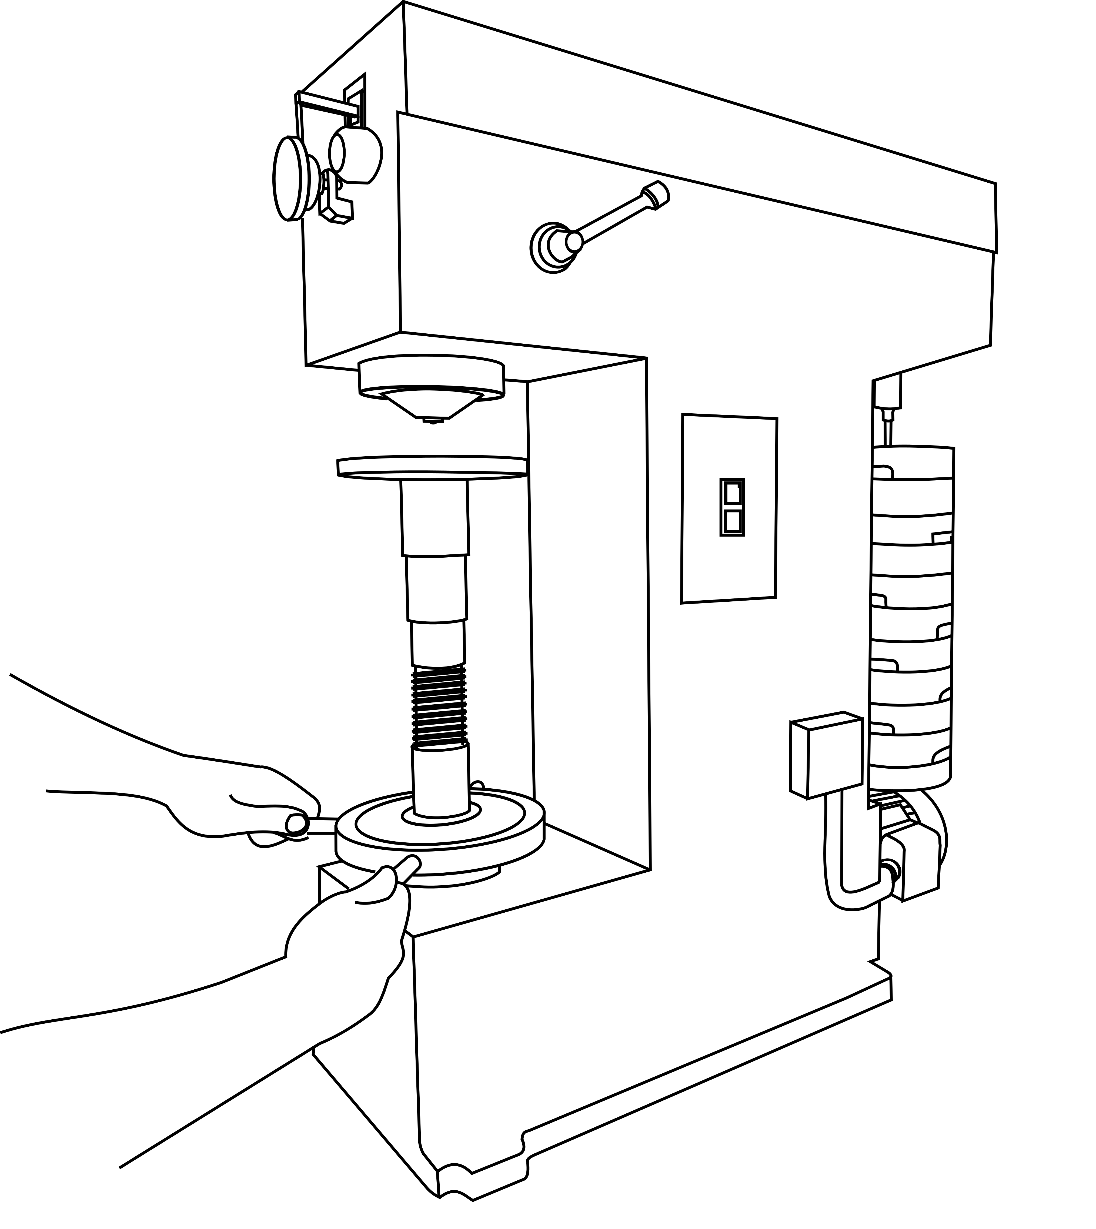

**STEP:** **➌** The motor is switched on by pressing power button. The hand lever is pulled into load position. The load is allowed to act on the specimen for a duration of 10 to 15 seconds. (SHOW THE SIMULATION)

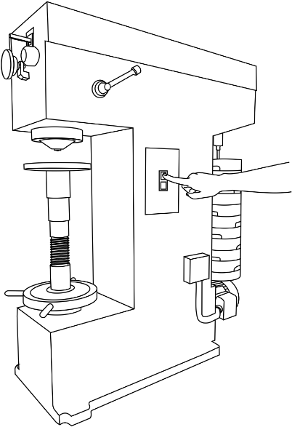

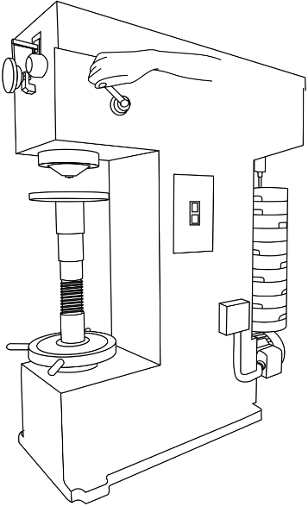

**STEP:** **➍** The hand lever is pulled back into unload position. The diameter of the impression is measured through a microscope attached to the apparatus.

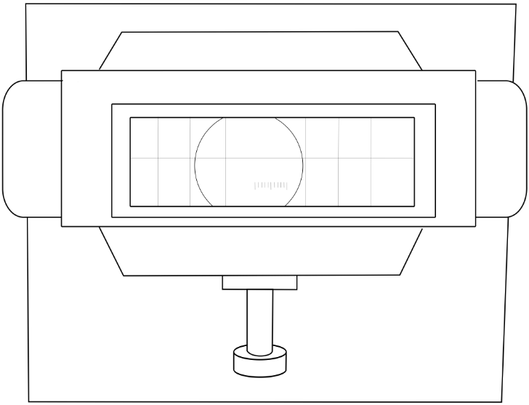

**STEP:** ❺ Calculate the Brinell Hardness Number (HBW)  
*[HBW (H from hardness, B from brinell and W from the material of the indenter, tungsten (wolfram) carbide)]*

|  |  |  |  |  |  |  |  |  |
| --- | --- | --- | --- | --- | --- | --- | --- | --- |
| Material | Trial No. | P/D2 | Load P (Kg) | Diameter of indentation (mm) | | Average diameter | d/D | F (Newton) |
|  |  |
| Sample  type |  |  |  |  |  |  |  |  |